General Work Description
Welcome to your very important work as course coordinator at CEMUS. Below is a generic work description in brief, applicable to all coordinators at CEMUS. Note that individual work descriptions may be different and are subject to change with increased work experience etc.
- Your job is to plan, deliver/facilitate, administer, evaluate and report a university course in accordance with your course syllabus and in close collaboration with a colleague and a course resource person/appointed educational coordinator. You will also collaborate with guest lecturers, the course work group (made up of experienced university teachers, researchers and professors), CEMUS director of studies and the larger team of educational and course coordinators at CEMUS in resource groups and otherwise.
- Work tasks include course planning, selection of course literature, contact with guest lecturers, preparation of (and often facilitating) seminars and workshops as well as course administration (including keeping track of your course budget and preannouncing lectures, answering student questions, facilitating the grading process and reporting grades) and course evaluation and reporting.
- Your work also includes participation in the four course assemblies, the course report conference and thematic Course Coordinator Series sessions (CCS-sessions).
- You are expected to participate in biweekly staff meetings
- For course assistants: to help facilitate and prepare resource group meetings

Please follow deadlines and instructions on the ccs webpage.

Project Plan [course name]
With thanks to the SDPMC-course for text, adapted by DM and SA connected to the ‘old’ template.

The Project Plan is the strategic plan for how you will organise and ‘realise’ the project. Most of your work as a course coordinator is the creative work of course planning and course implementation. To facilitate the process, you and your course coordinator colleague also write a project plan that describes your work together. The project plan is a tool for your planning and a very much a living document. Use this as a tool at the beginning to start formulating together what it is that you want to achieve, and how. It is a tool for discussion. Note some of the things you discuss, and hand in the document.

Project​ ​Vision​ ​Statement – What is your vision for this project?
A vision statement is a succinct, future-oriented declaration of the project’s purpose and aspirations. It should describe WHY you are conducting your project and the change you want to create.
[YOUR TEXT]

Project​ ​Goals and ​​Objectives – what will the project accomplish?
Goals are the WHAT of the process – speaking broadly, what will the project accomplish? Write short (no more than two-three) clear statements that explain what the goals of the project are. (Think also how these connect to your general work description and course syllabus, since these two sets the limits to what you can and should do).
[YOUR TEXT]

Objectives also indicate what you plan to achieve with your project but emphasise HOW you will reach your project goals. Objectives are typically more focused than the broader Project goals, and are S.M.A.R.T (Specific, Measurable, Assignable, Realistic and Time-bound). The course syllabus is a key document here. These are also connected to your work description above, where at least some objectives can be found. Use this as an opportunity to reflect upon what the tasks are and if you want to add something or if you think that some are more important than others.
[YOUR TEXT]

Team​ ​and​ ​Resources – Who are the key team members and required resources?
Outline your team structure, including names and primary project skills and responsibilities. Do you know whom to contact for different questions (also see cc-guide).
[YOUR TEXT]

Success​ ​Factors​ ​– How will you know when you have succeeded in a particular phase?
Discuss potential ways you can assess the success of your project. Are there any frameworks you can use/adapt/create? What is the limitation of such a framework if so?
[YOUR TEXT]

Challenges – What are the challenges and risks of your project?
Write a list of potential risks that can delay the project. Think about internal risks (things like procrastination, a project member getting ill, etc.) and external risks (external factors that may influence the project, for example stakeholders, political processes, etc). What are ways to deal with these challenges?
[YOUR TEXT]

EXTRA RESOURCE:

The section below does not need filling in at this stage, but can be a useful tool for upcoming work planning.

Stages​ ​and​ ​Tasks – What do you need to do and when do you need to do it?
Outline the different tasks required for your project to happen. As part of this section, complete a Work Breakdown Structure (WBS) for this stage of your project. A work breakdown structure is a hierarchical and incremental decomposition of the project into different phases, and deliverables. It is a tree structure, which shows a subdivision of effort required to achieve an objective.

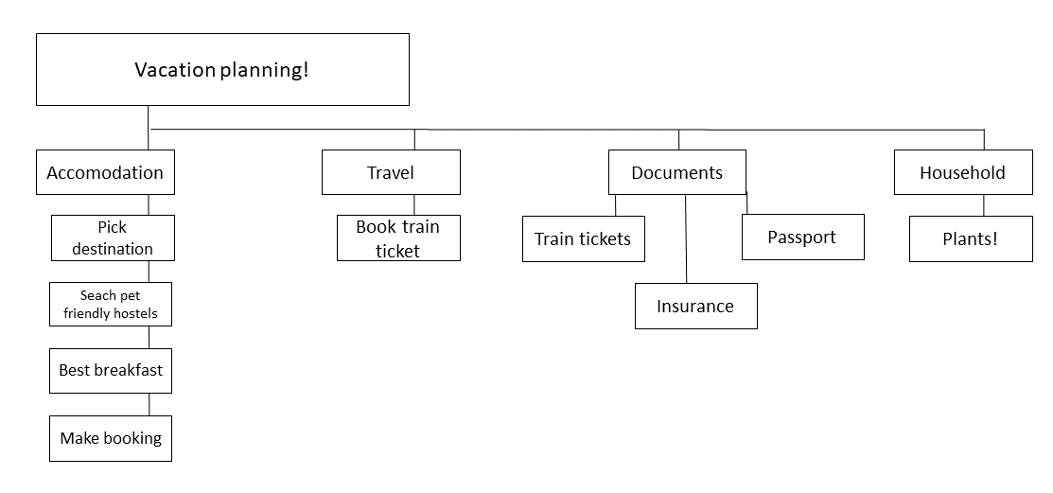
Figure 1: Example of a general work breakdown structure

Keep the WBS visual and detailed. Breaking down your tasks as much as possible within your project scope will help ensure no tasks fall through the cracks. Address WHEN these different tasks must be realised and WHO is responsible for each task. These should be regularly updated as the project progresses and the work plan is updated. At www.web.cemus.se/ccs you can find a list of deadlines.

