GLOBAL CHALLENGES
and
SUSTAINABLE FUTURES

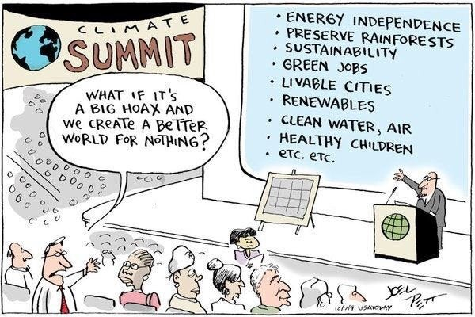

We warmly welcome you to ‘Global Challenges and Sustainable Futures’ 2022.

What are the challenges, humanity is facing humanity today? How might the ways we think affect our future, especially concerning justice and sustainability? How might we interact with these questions in the present to enact transformations for sustainability?

During the course we will meet weekly to focus on current global issues, rethink the way we look into the future and explore strategies for transformational change. During our lectures we will explore sustainability challenges on different scales, from the global to the local, and from the future to the present. We hope that you will enjoy taking different perspectives on tackling the challenges of our time. Throughout the semester, different perspectives and approaches are analysed and discussed in sessions with inspiring guest lecturers, in order to offer a multidisciplinary understanding of current sustainability issues and different trajectories into the future. Along the way, we will explore our own role in the causes and solutions of these sustainability challenges.
Registration
Please remember to register for the course. You have received information about how to register in your admission letter.
First Class
The first session of the course will take place on ​Tuesday, August 30th, at 17.15 in the room Sydney Alrutz in the building Blåsenhus. You can find this room and other university locations by searching at ​https://link.mazemap.com/WFSAZqZT .

CEMUS Introductory Lecture and Open Events
At CEMUS we start every semester with open, inspirational and introductory lectures for all courses and to a public audience. This year’s ​introductory lecture will take place on August 29th, 18:15-20:00​ with a start-up panel “Transcending Boundaries CEMUS +30 – Transforming Learning, Universities and the World” in Sal X in the University Main Building.
In addition, on ​September 15th, from 16.15-18.00​, the ​CEMUS Project Café will take place at CEMUS Library. Students, CEMUS staff, faculty and the interested public are warmly welcome to an inspiring and creative afternoon. You can bring your own ideas and projects or just come and listen (and get involved) in what's going on this autumn semester at CEMUS and beyond. Please keep visiting the​ ​CEMUS website​ for further information and more open events.

Course Structure
The course is worth 7,5 credits (ECTS) and is thus given at 25% of a full-time study workload, which equals around 10 hours per week. Class is on Tuesday evenings from 17:15 to 19:00, for the entire autumn semester. Acknowledge however, that some session will take longer and therefore continue after 19:00. All classes will be held in in the room Sydney Alrutz at Blåsenhus.

Our offices are located at the CEMUS department at Geocentrum. However, as we only work part time it is best to email us in the first instance rather than drop-in. To provide you with a faster answer, please reach out to both of us!

The course is divided into three modules: Global Challenges (Module I), Sustainable Futures (Module II) and Local Opportunities & Better Presents (Module III). More information on course content and assignments are provided in the accompanying documents ‘Schedule for students’ and ‘Examination Structure for students’, as well as on Studium.
Latest Updates & Questions
On www.cemus.uu.se/gcsf you can find the latest information and updates. If you have any questions regarding the course, please contact us at enki.simmons@cemus.uu.se and lara.kerschl@cemus.uu.se. To ensure quicker responses, please include both of us in emails.
We are looking forward to meeting all of you!

Warmly,
Enki Inkpen Simmons and Lara Kerschl Course Coordinators GCSF 2022

