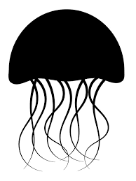
Perspectives on Climate Change Ecopsychology, Art & Narratives
Examination structure
Type of examination | Credits | Grading | Format
Written Preparation | 0.5  1.5 | Pass/fail | Short reflection on module 1 content  (13th February)  Reflective essay on module 1 and 2 content  (20th March)
Active Participation in seminars and workshops | 0.5 | Pass/fail | Attendance of Through Other Eyes workshop session  (7th February, 17-19)
 | 0.5 | Pass/fail | Presentation on artistic case study  (7th March, 17-19)
 | 0.5 | Pass/fail | Attendance of creative processes workshop (21st March, 17-19)
Oral presentation | 0.5 | Pass/fail | Presenting project work and peer feedback  (23rd May, 17-19)
Written documentation of project work | 3.5 | Fail, 3, 4, 5 | Written documentation of project work  (Hand-in 2nd June, 17.00)
 | Total: 7.5 Credits
Find more information about course goals on the course webpage: http://www.cemus.uu.se/poc/

